LAB ASSIGNMENT 2.1

**Benzene**

1. Inside your GraphicsIntro project, create a new class called Benzene. The class should look like the following:

|  |
| --- |
| import gpdraw.*;  public class Benzene  {  private DrawingTool pencil;  private SketchPad paper;    public Benzene(){  paper = new SketchPad(300, 300);  pencil= new DrawingTool(paper);  }    public void draw(){  //Your code goes under here  }  } |

1. Create the following shape.

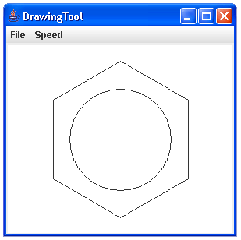

1. Inside the Benzene class, change the draw()method to be called drawHexagon(int side). The (int side) part of the statement, is called a parameter.
2. Create a new method in the Benzene class, called drawCir(int radius).
3. Place the code exclusively for the circle in the drawCir(int radius) method.
4. Leave the code exclusively for the hexagon in the drawHexagon(int side) method.
5. Create a new class, called PracticeDraw, in your Benzene project.
   1. Inside the class, clear out all code inside the class.
   2. Create a main method(), like shown below:

public static void main(String[] args){

}

1. Inside the main method:
   1. create an object of the class Benzene called benOne.
   2. Call benOne’s method drawCir(400)
   3. Call benOne’s method drawHexagon(200)
2. Run your code!
3. Include your name as a documentation statement and also a brief description of the program at the top of Benzene project.